|  |
| --- |
| ArcGIS Server & Portal Installation  AWS AMI Configuration  James Moloney |



Creative Commons information

© State of Queensland (Department of Transport and Main Roads) 2015

88x31

<http://creativecommons.org.licences/by/4.0/>

This work is licensed under a Creative Commons Attribution 4.0 Licence. You are free to copy, communicate and adapt the work, as long as you attribute the authors.  
The Queensland Government supports and encourages the dissemination and exchange of information. However, copyright protects this publication. The State of Queensland has no objection to this material being reproduced, made available online or electronically but only if its recognised as the owner of the copyright and this material remains unaltered.

|  |  |
| --- | --- |
| Interpreter_Symbol | The Queensland Government is committed to providing accessible services to Queenslanders of all cultural and linguistic backgrounds. If you have difficulty understanding this publication and need a translator, please call the Translating and Interpreting Service (TIS National) on 13 14 50 and ask them to telephone the Queensland Department of Transport and Main Roads on 13 74 68. |

Disclaimer: While every care has been taken in preparing this publication, the State of Queensland accepts no responsibility for decisions or actions taken as a result of any data, information, statement or advice, expressed or implied, contained within. To the best of our knowledge, the content was correct at the time of publishing.

Document control options

Departmental approvals

Refer to the appropriate Risk Assessment Tool for relevant reviewer and approver

|  |  |  |  |  |
| --- | --- | --- | --- | --- |
| Date | Name | Position | Action required  *(Review/endorse/approve)* | Due |
|  |  |  |  |  |
|  |  |  |  |  |

Risk level

GACC major  GACC minor  High risk (but not GACC)  Medium risk

|  |  |
| --- | --- |
| Prepared by |  |
| Title |  |
| District & Region |  |
| Branch & Division |  |
| Project/program |  |
| Project number |  |
| Project location |  |
| Status |  |
| DMS ref. no. |  |

Contents

[About 1](#_Toc43291328)

[ESRI Enterprise Amazon Machine Images 1](#_Toc43291329)

[Licenses 1](#_Toc43291330)

[Enable IIS 1](#_Toc43291331)

[Server Certificates 2](#_Toc43291332)

[Enable https on Port 443 3](#_Toc43291333)

[ArcGIS Server 6](#_Toc43291334)

[Authorize the software 6](#_Toc43291335)

[Start the Service 6](#_Toc43291336)

[Configure ArcGIS Server 7](#_Toc43291337)

[Import ArcGIS Server Certificates 9](#_Toc43291338)

[Portal for ArcGIS 12](#_Toc43291339)

[Start the Service 12](#_Toc43291340)

[Configure Portal for ArcGIS 12](#_Toc43291341)

[Configure the Web Adaptors 16](#_Toc43291342)

[Portal 16](#_Toc43291343)

[Server 17](#_Toc43291344)

[Federate ArcGIS Server with Portal 19](#_Toc43291345)

[Hosted Datastore for Portal 21](#_Toc43291346)

[Create 21](#_Toc43291347)

[Get Database Credentials 23](#_Toc43291348)

[Login to the Datastore Database 24](#_Toc43291349)

[Creating a new Login Role 25](#_Toc43291350)

[Creating a new Schema 27](#_Toc43291351)

[SDE Connection 27](#_Toc43291352)

[ArcGIS Pro 27](#_Toc43291353)

[ArcGIS Server 27](#_Toc43291354)

[Creating and Publishing Data 27](#_Toc43291355)

[Create Feature Layer 27](#_Toc43291356)

[Create Spatial View 27](#_Toc43291357)

[Create Materialized View 27](#_Toc43291358)

[Publish Feature Class or View as a Service 27](#_Toc43291359)

Table of Figures

No table of figures entries found.

Table of Tables

No table of figures entries found.

# About

This document explains the process of configuring and ESRI Enterprise Amazon Machine Image (AMI). All documentation is based around the configuration of ArcGIS Server and Portal version 10.8. Future AMI's may have slightly different configurations.

# ESRI Enterprise Amazon Machine Images

Information regarding the setup and launching an ESRI enterprise AMI can be found here <https://enterprise.arcgis.com/en/server/latest/cloud/amazon/arcgis-server-amis.htm>

# Licenses

You will need 2 license files to complete this installation

* Server – An ArcGIS server PRCV license file that has not been activated before
* Portal – An ArcGIS Portal .json license file that has not been activated before

# Enable IIS

By default, the ESRI AMI will have World Wide Publishing Services switched off. You will need to open the Services manager and scroll to the bottom and enable for the server to start serving web pages. Start it and set to automatic so next time the server restarts it will start WWWPS automatically.

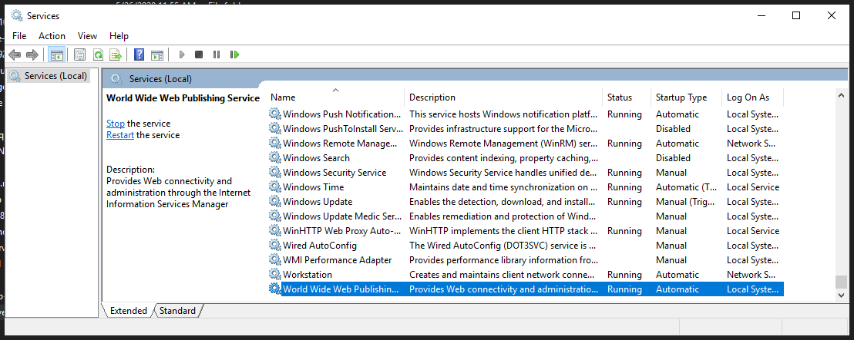

# Server Certificates

Once the server IP address and host name of your AWS machine is known, you will have to create a certificate request and have a certificate authority generate the server certificate. This is required as ArcGIS Portal will only federate with ArcGIS Server over HTTPS (ie, use the installed ArcGIS Server as the datastore and so on..)

To generate a certificate request for the server got to IIS manager, click on the server Certificates

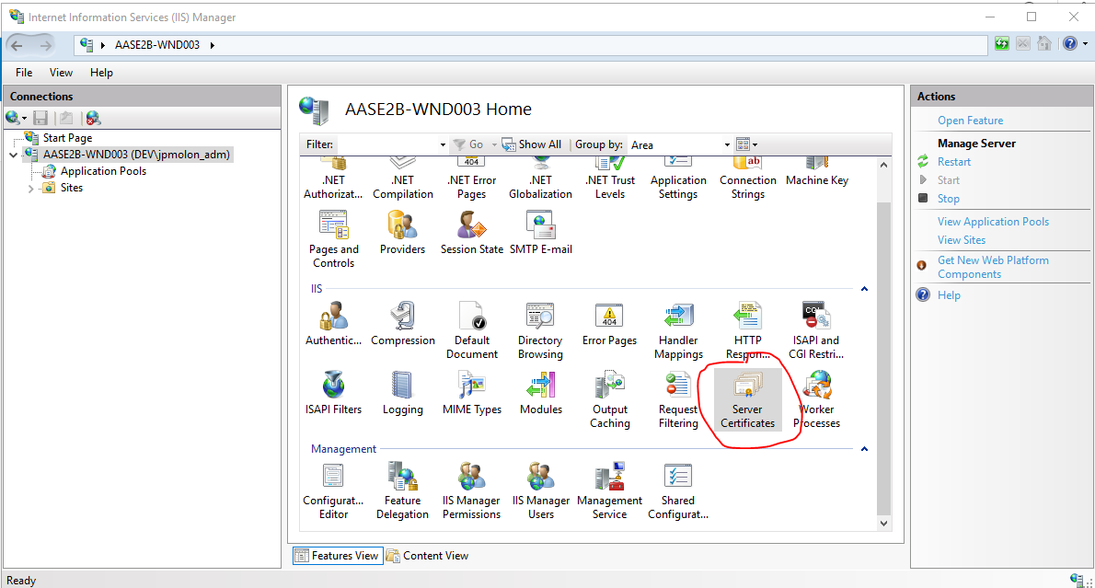

Click Create Certificate Request

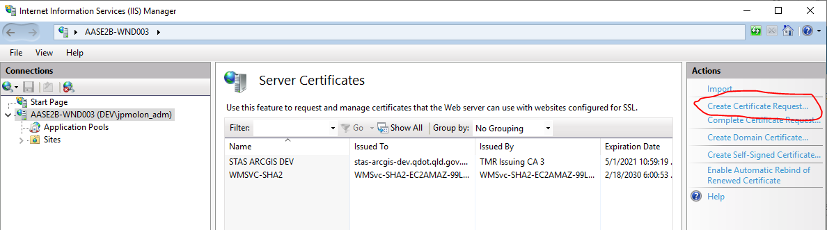

Fill out the form and save the file.

Send this off to Certificate authority to generate certificate.

At TMR this can be requested with (….NEED TO GET DETAILS…)

In the TMR Environment you will need the Root CA, as well as the full certificate chain for the server.

**NOTE: It will be required later that the certificates are in separate files, not all in one, as ArcGIS Server will require them separately.**

## Enable https on Port 443

Once you have received the server certificates, import the certificates in IIS management console.

Click on server at root level and select Server Certificates

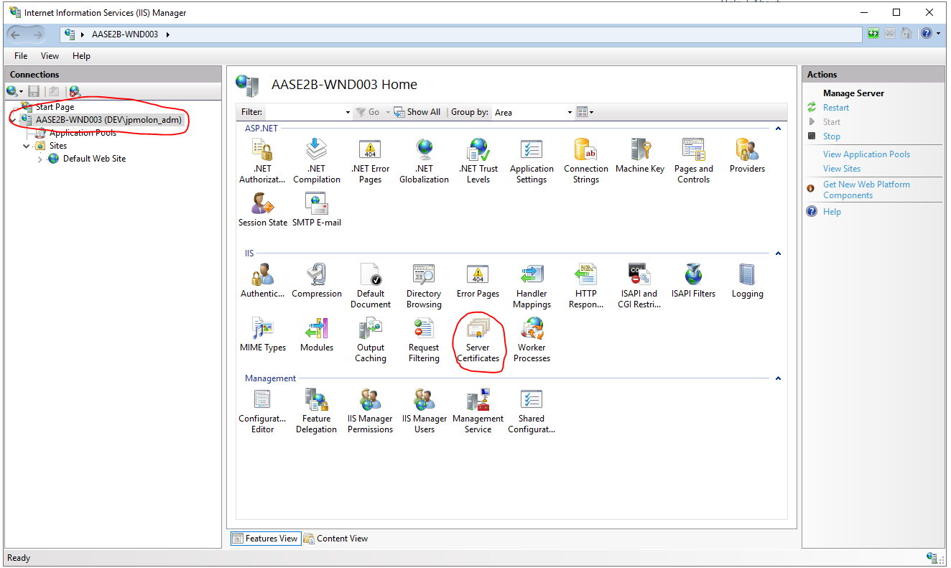

Click import at the top right of the console.

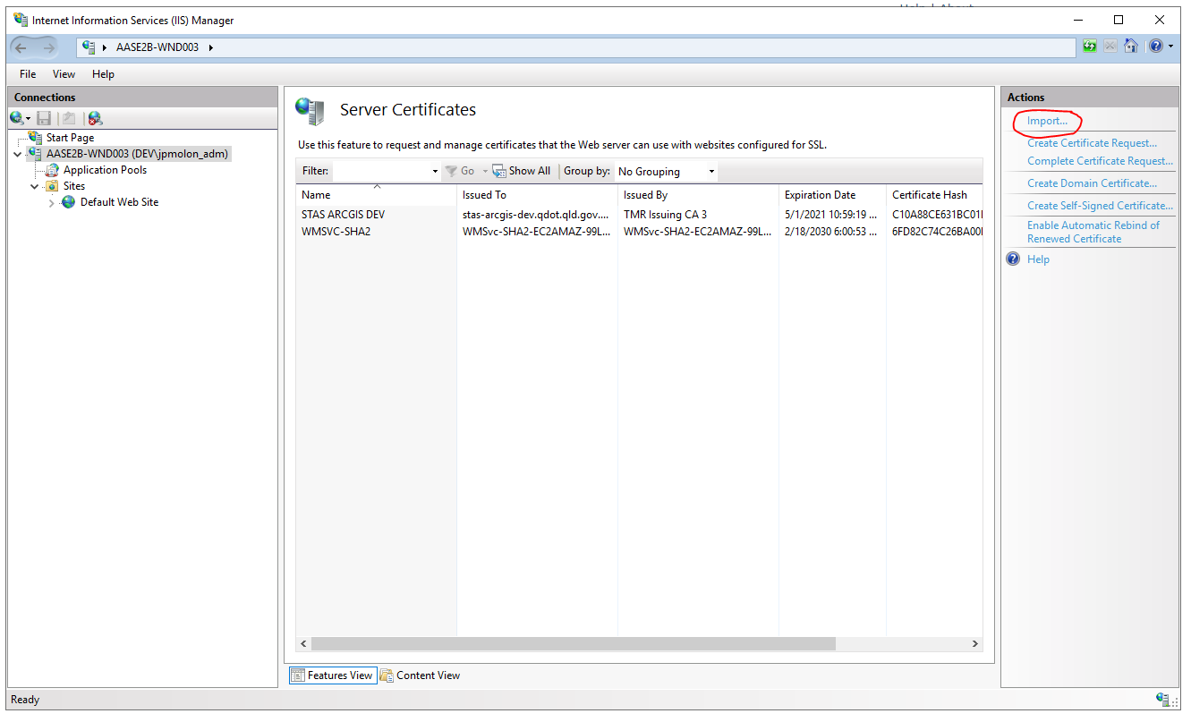

Navigate to the server certificate, if they ave a password, enter details and click ok

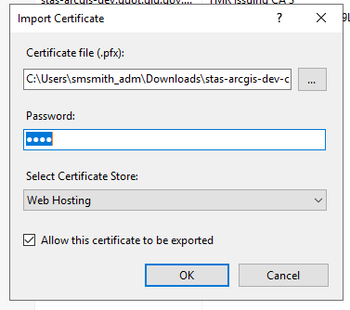 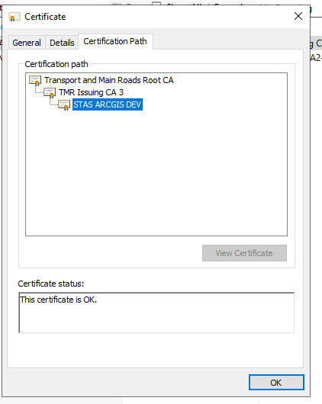

You should have something that looks like this.

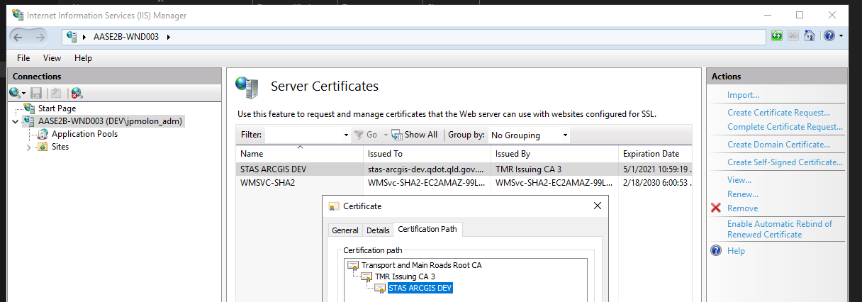

Make sure you restart the server, as the certificate will not take effect until restart is complete.

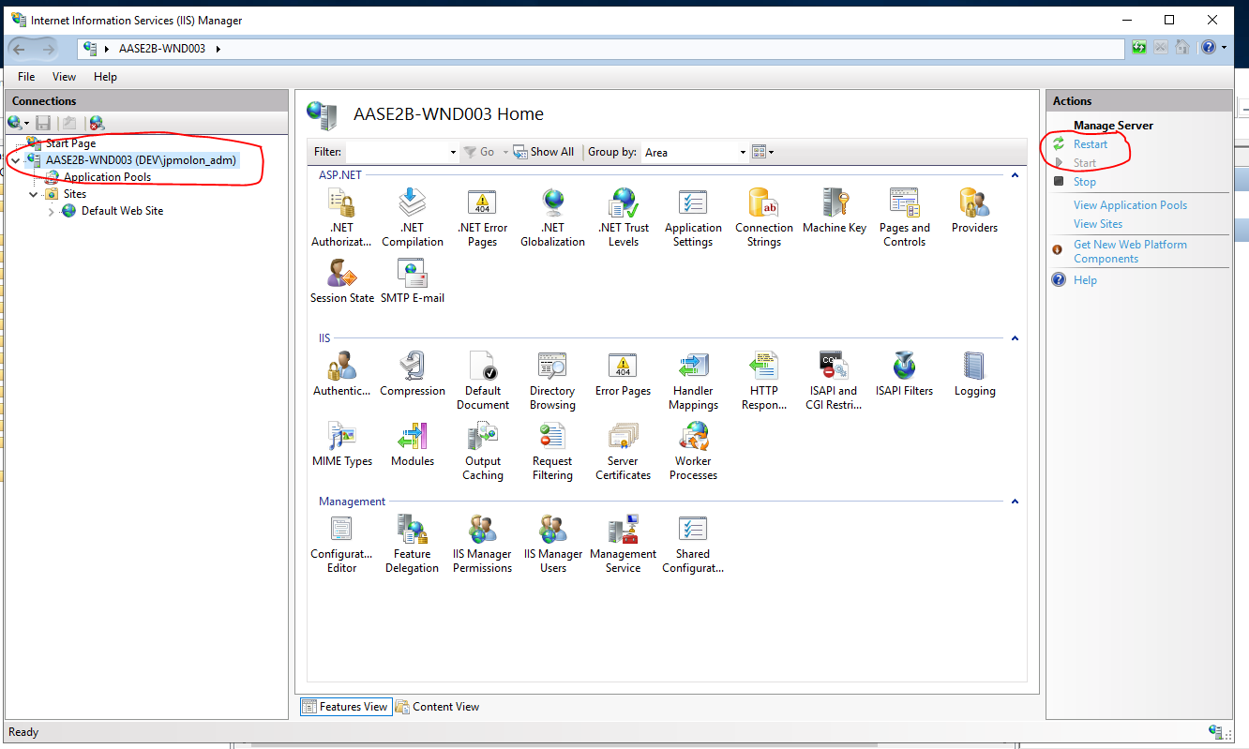

Navigate to Server fully qualified domain name and test that server is trusted

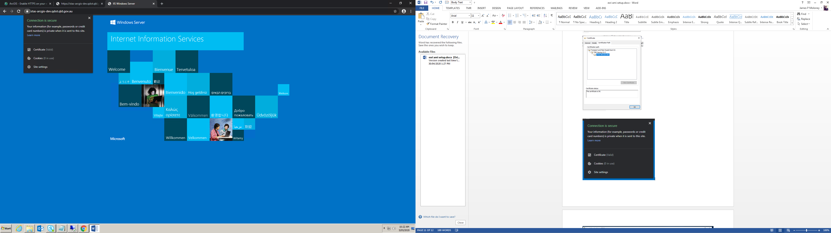

# ArcGIS Server

## Authorize the software

With the PRCV license file, open the Software Authorization for ArcGIS Server tool from the window menu.

Browse to the license file and finish the authorization process.

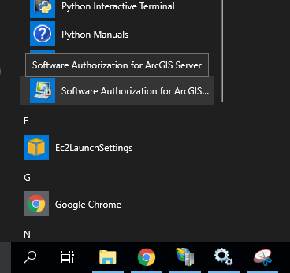 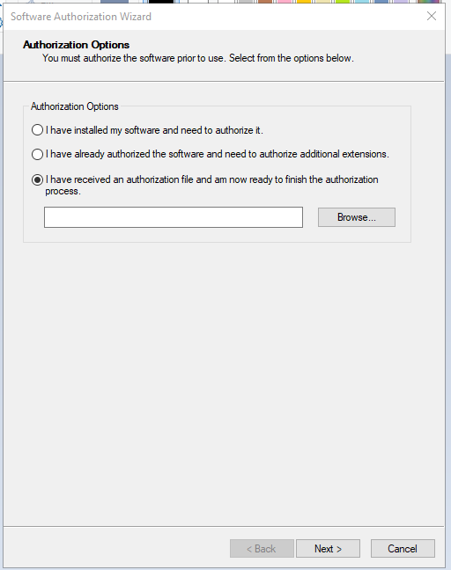

## Start the Service

In the Services Manager, Start the ArcGIS server service. Set to automatic. Make sure ArcGIS Data Store is running too!

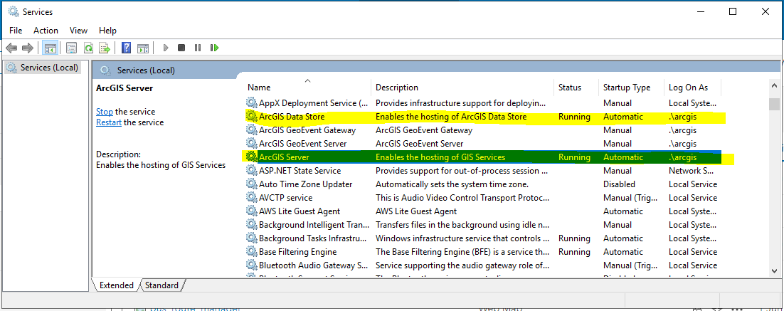

## Configure ArcGIS Server

Open ArcGIS server manager from the windows menu or open a browser and navigate to

<https://localhost:6443/arcgis/manager>

You should be presented with the ArcGIS Server Setup Wizard.

If this machine is hosting its own site, create a new site. *This document does not cover joining existing sites…*

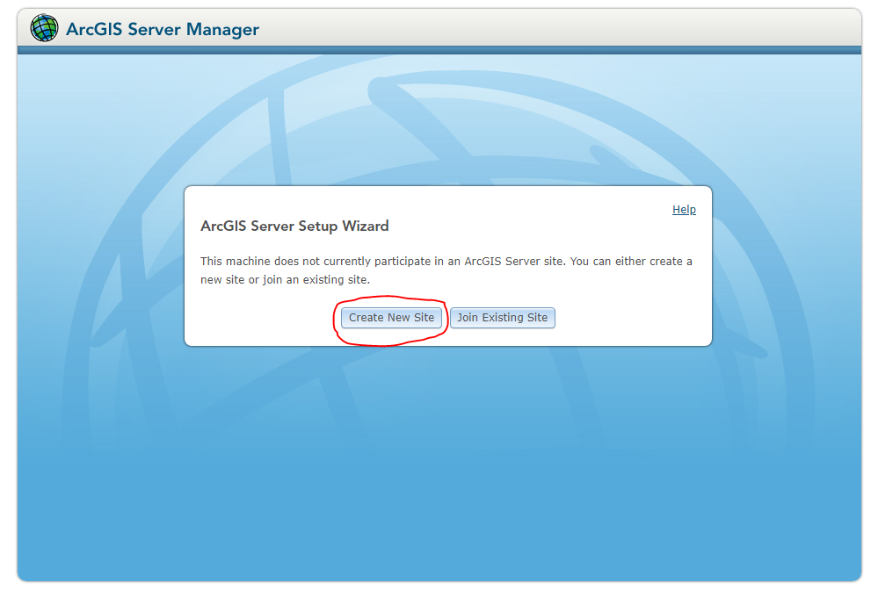

Create primary site admin account

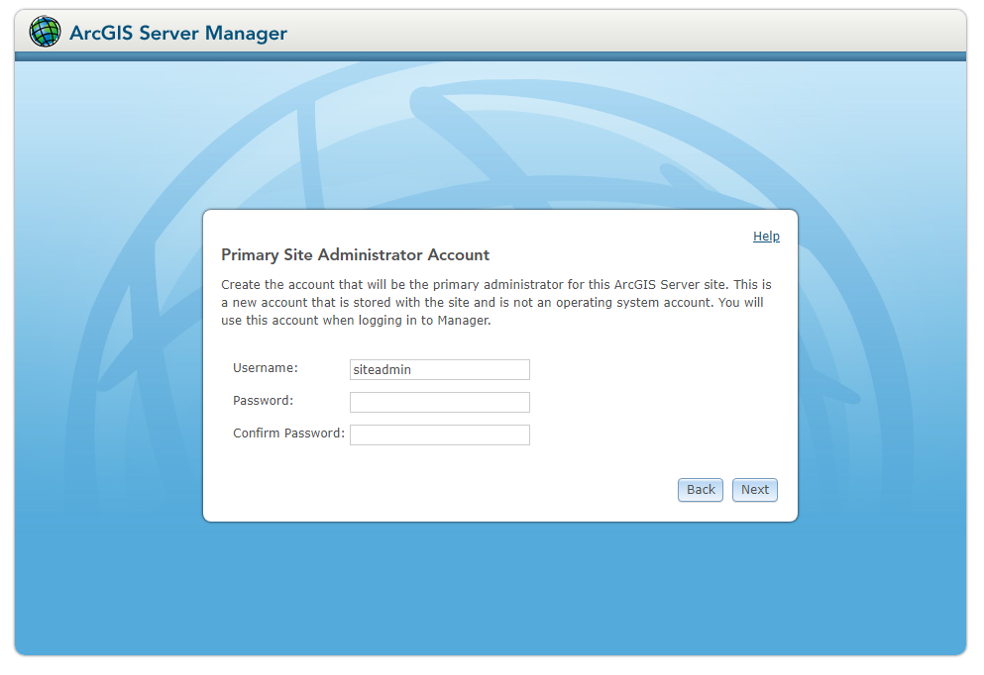

Any username will do, I prefer to use the suggested default. SAVE THIS INFORMATION SOMEWHERE SECURE

Username: siteadmin

Password: password

Click Next

Specify Root Server Directory and Configuration Store

Leave defaults unless you want to install on another drive/location..

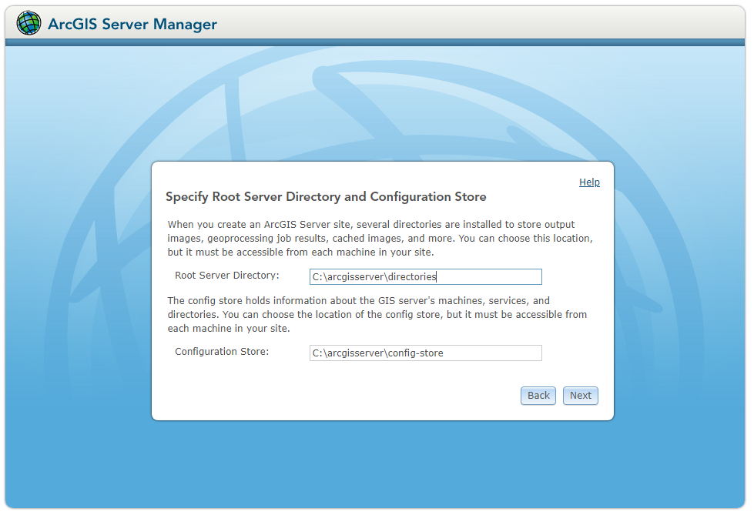

Click Next

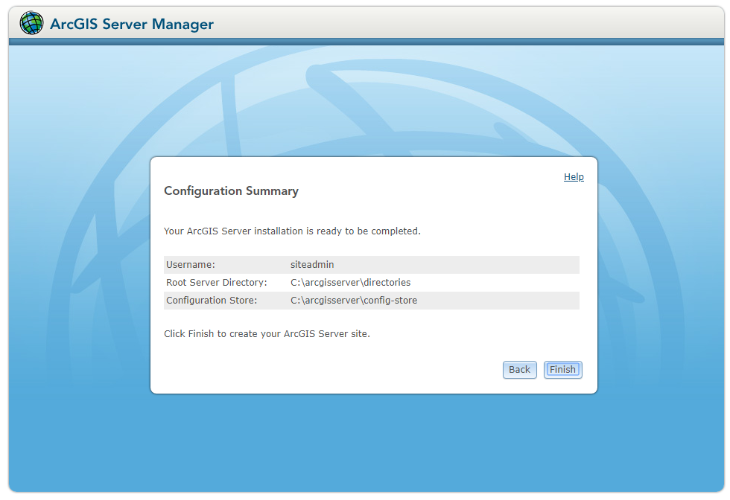

FINISH and WAIT!!!

If all goes well you should be prompted to login to server with site admin user

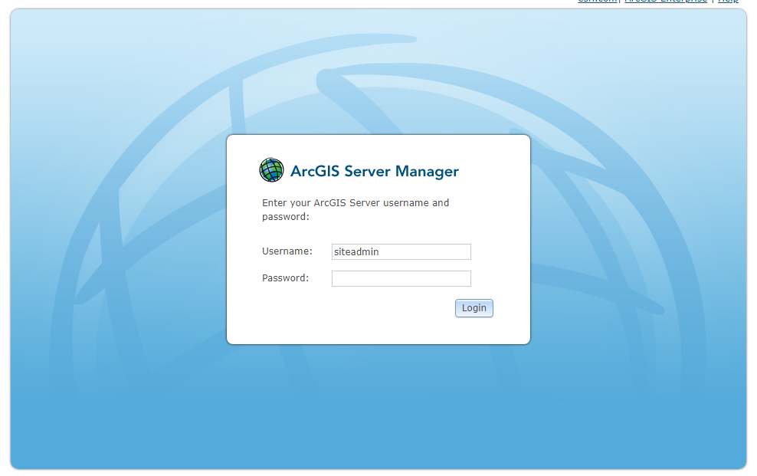

You should now have ArcGIS server running ☺

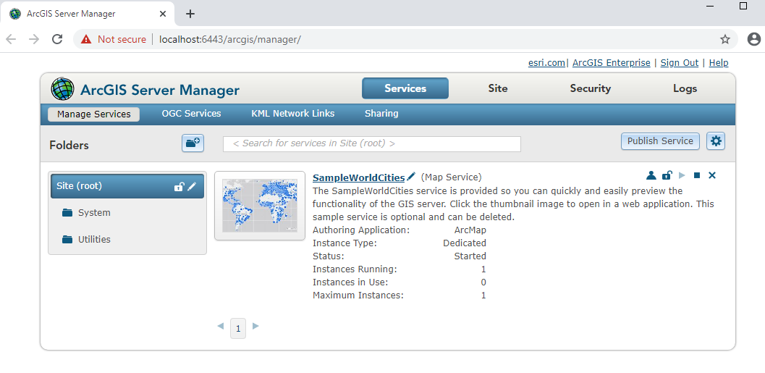

## Import ArcGIS Server Certificates

Import Server Certificates for ArcGIS Server to communicate on port 6443. This is required for ArcGIS Server to communicate on port 6443 with a trusted connection.

This will be vital for federating portal with ArcGIS server as ArcGIS server only communicates through port 6443 for SSL

These certificates need to be made available via the admin tools

Now that we have server running, navigate to (replace with you server name)

<https://stas-arcgis-dev.qdot.qld.gov.au:6443/arcgis/admin/login>

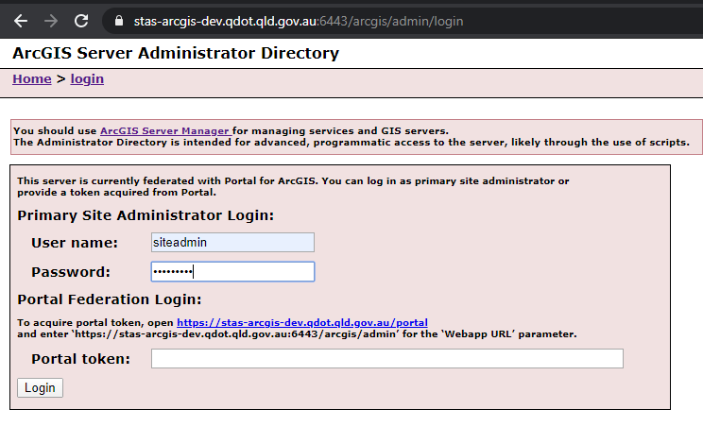

Navigate machine > machine ip > sslcertificates

First you will need to import root ca, then intermediate

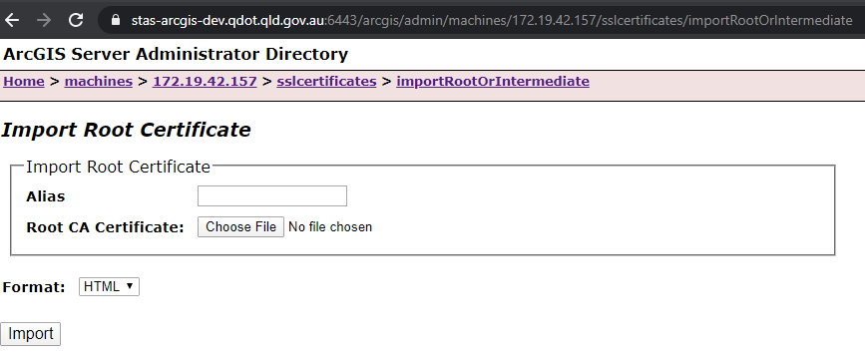

Then import existing server cert

Make sure you have the cert password handy

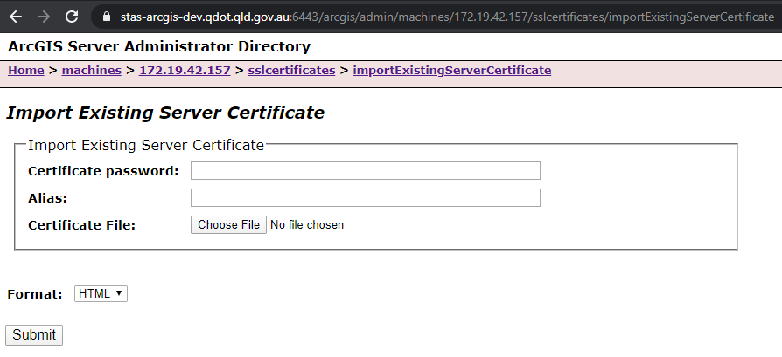

In the TMR environment, you should now have 3 certificates the ArcGIS Server can use for SSL communications outside of IIS.

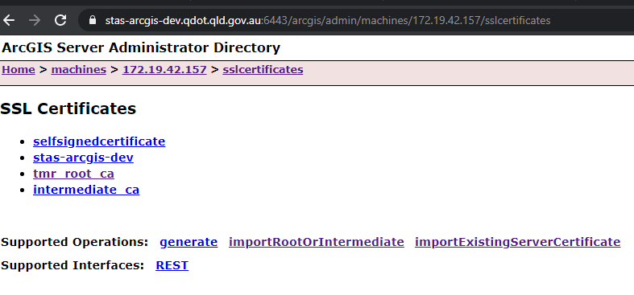

ArcGIS Server will restart, so you will have to wait 5mins for it to be back up and running. Be patient 😊

# Portal for ArcGIS

## Start the Service

Open the services console and start the Portal for ArcGIS service

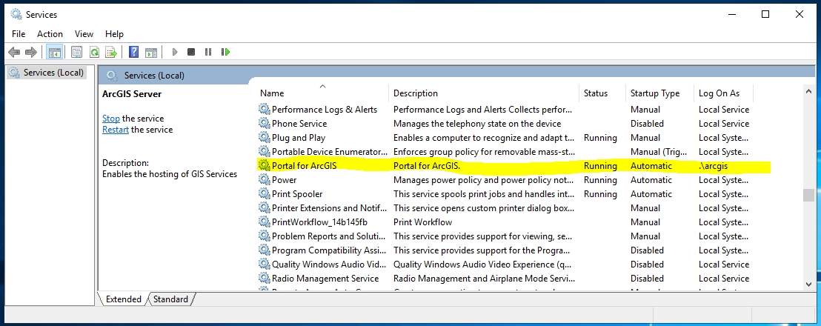

## Configure Portal for ArcGIS

With a portal license file from MyEsri a\_license.json file

Open Portal for ArcGIS from the windows menu

This should direct you straight to Create or Join a Portal

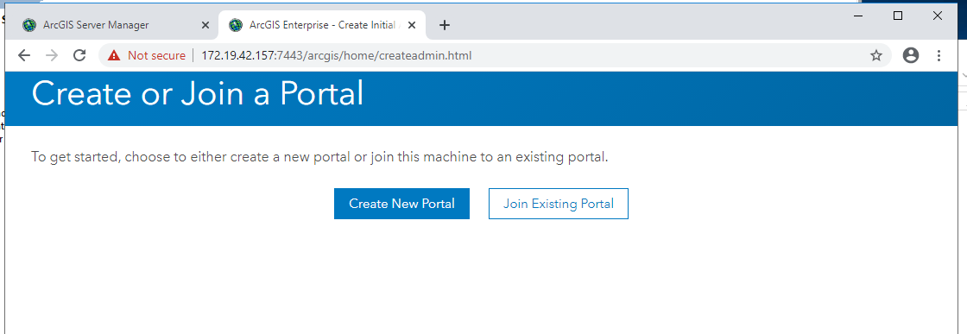

Import License file

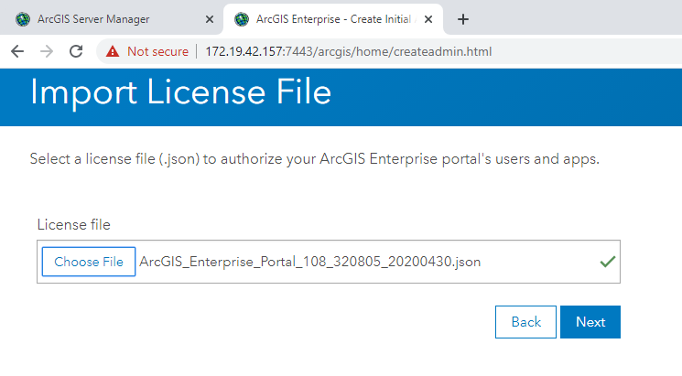

Create Initial Administrator Account

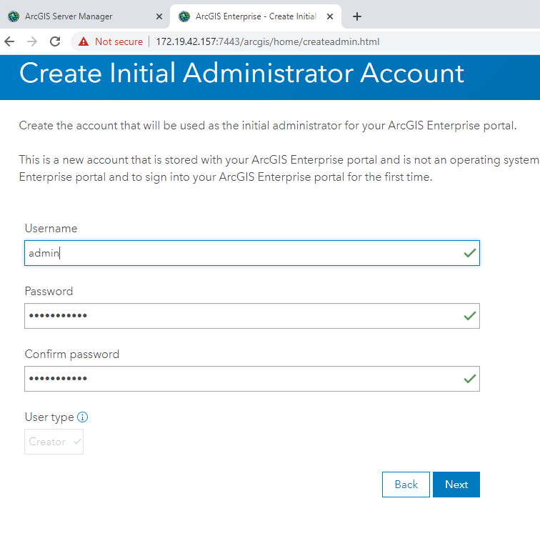

Username: admin

Password: password

SAVE THIS INFORMATION SOMEWHERE SECURE

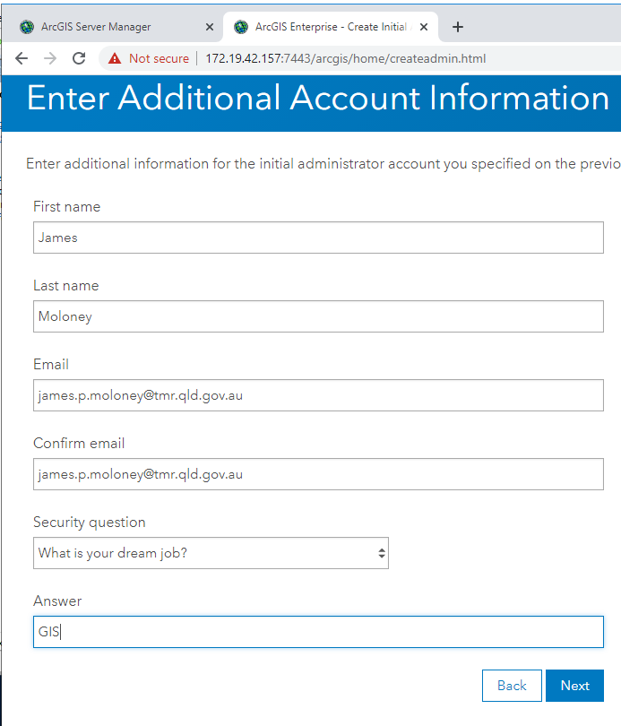

Accept default location unless required to be install in other drive etc

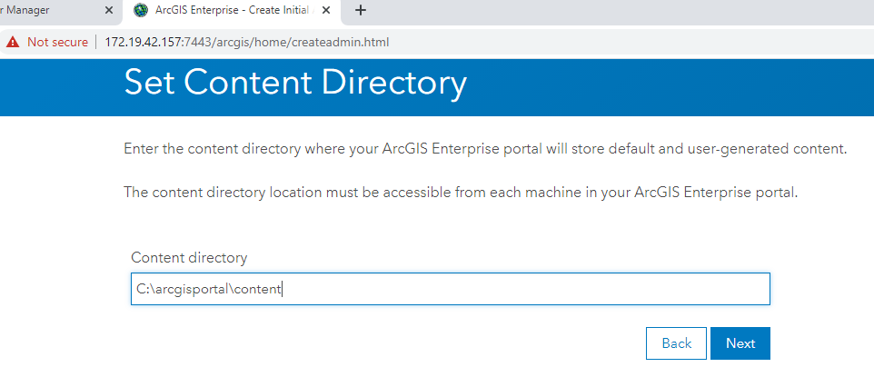

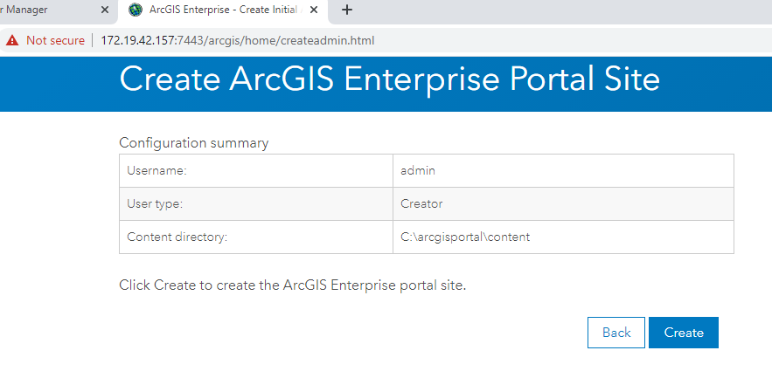

This takes a while so WAIT!!

If all goes well you should get this message

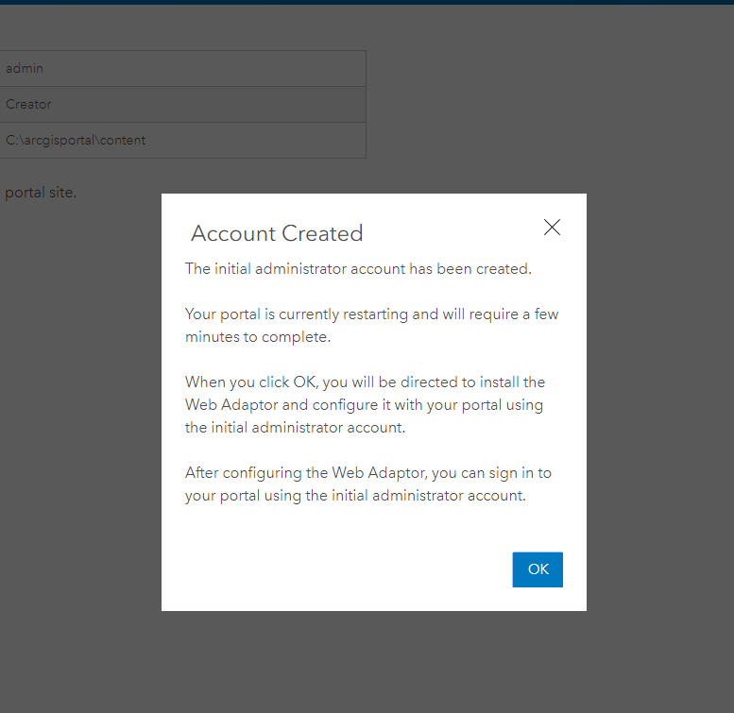

# Configure the Web Adaptors

This is required for routing traffic through the server fully qualified domain name to ArcGIS Server and Portal services.

## Portal

In the start menu navigate to portal web adaptor

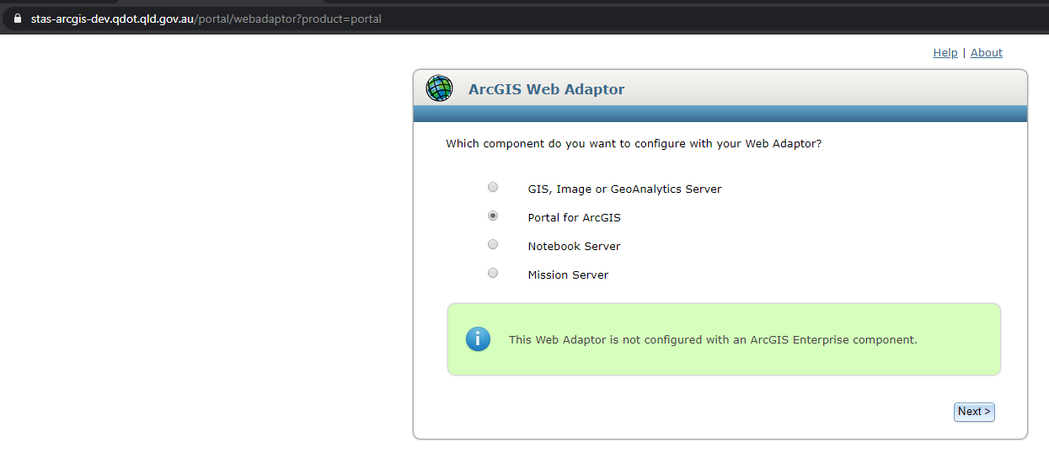

Entr fully qualified domain name and an admin username and password

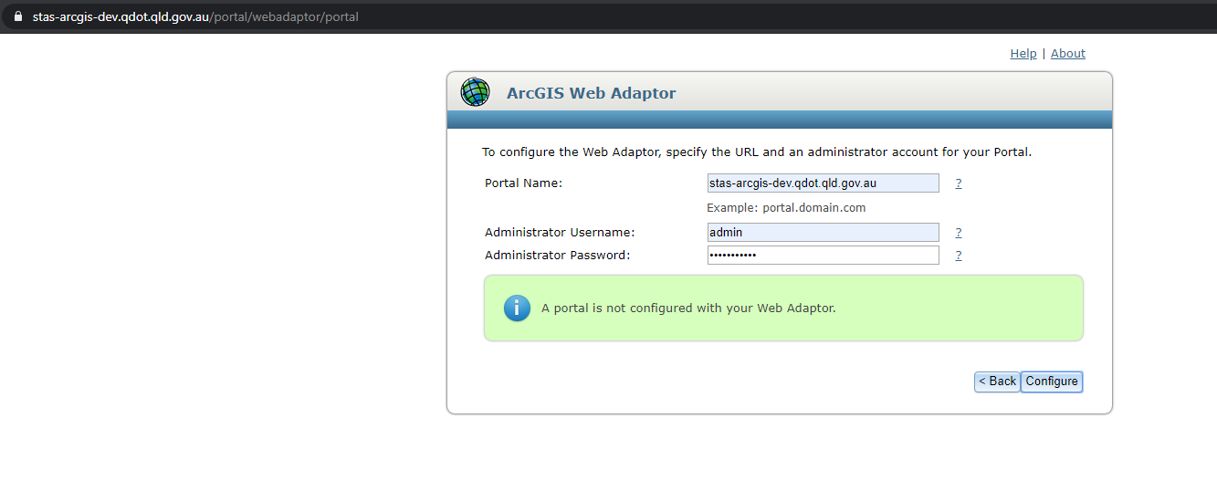

WAIT… This can take ages….

You should now be able to access portal from the fully qualified domain name.

For example, <https://stas-arcgis-dev.qdot.qld.gov.au/portal/home/index.html>

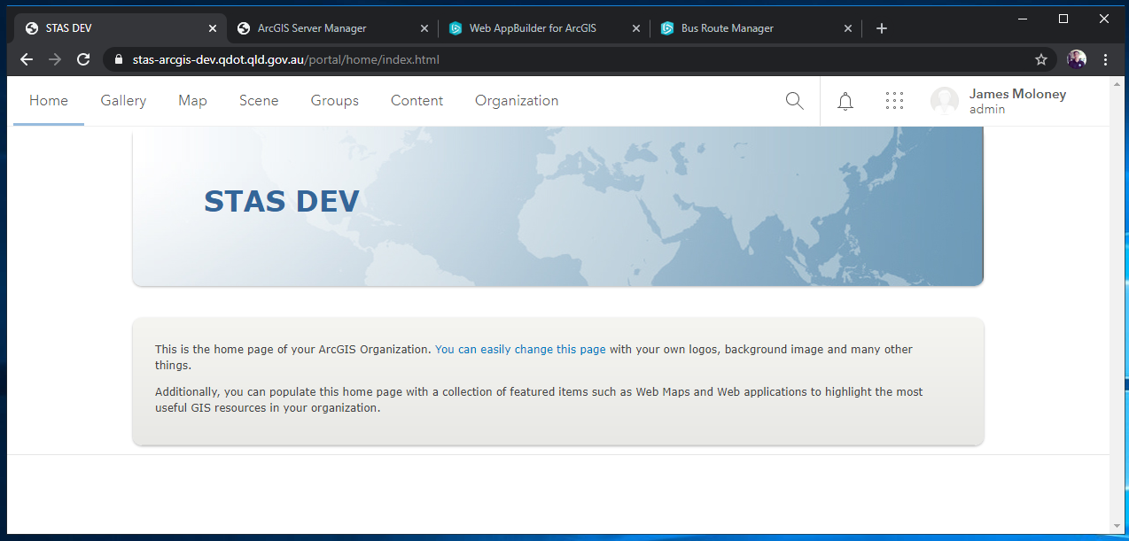

## Server

In the start menu, navigate to the server web adaptor

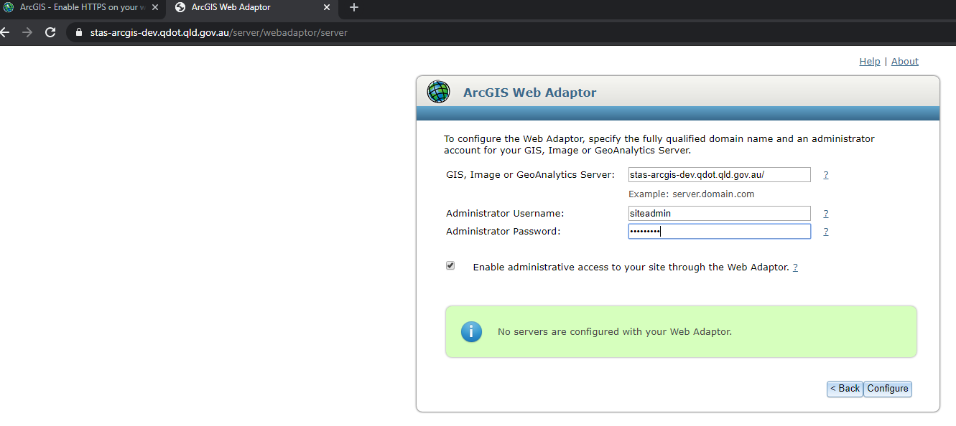

Enter the fully qualified domain name and the server site admin username and password

It is also recommended to check the Enable administrative access to your site the web adaptor, to ensure all admin tasks can be conducted via the fully qualified domain.

Navigate to https://{fully-qualified-domain-name}/server/rest/services to confirm the web adapter is working

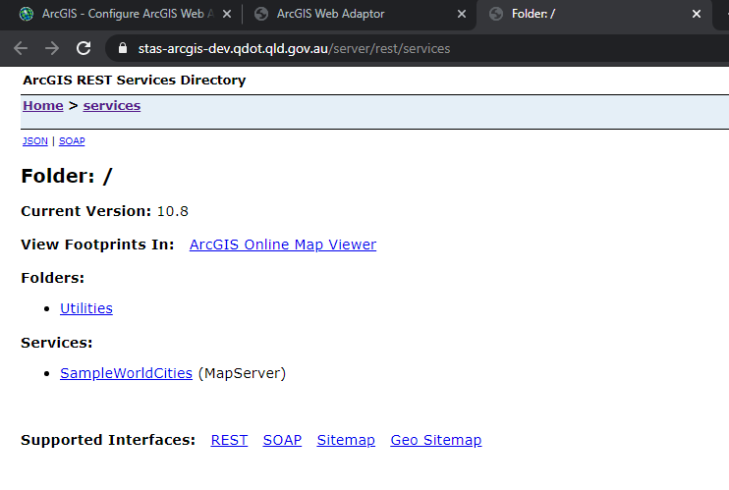

You should also now be able to access the ArcGIS Server manager via fully qualified domain name.

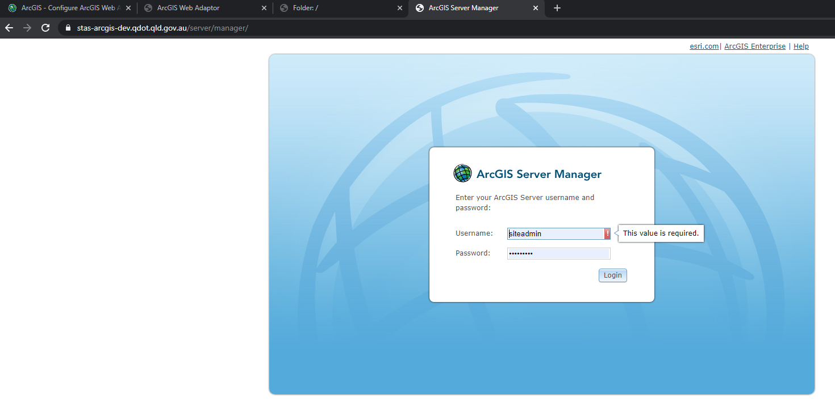

# Federate ArcGIS Server with Portal

Now that you have server and portal running under a fully qualified domain name, you add server sites to your ArcGIS portal instance.

To do this, log in to portal as an administrator, navigate to the organisation tab and click on settings. From there you will select servers from the left hand side menu and click add server

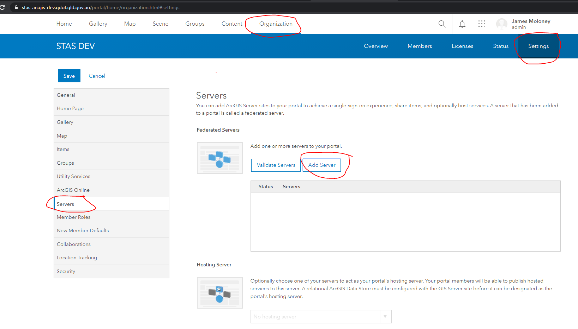

Enter you server details in the dialog provided. See example below

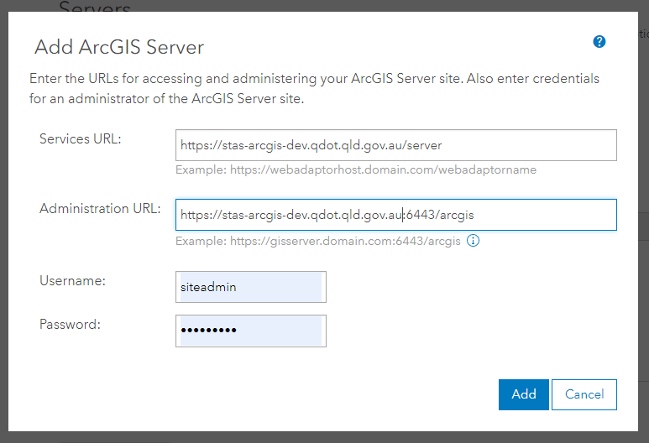

If the details are correct, and everything checks out, you should now have a server federated with your Portal for ArcGIS instance.

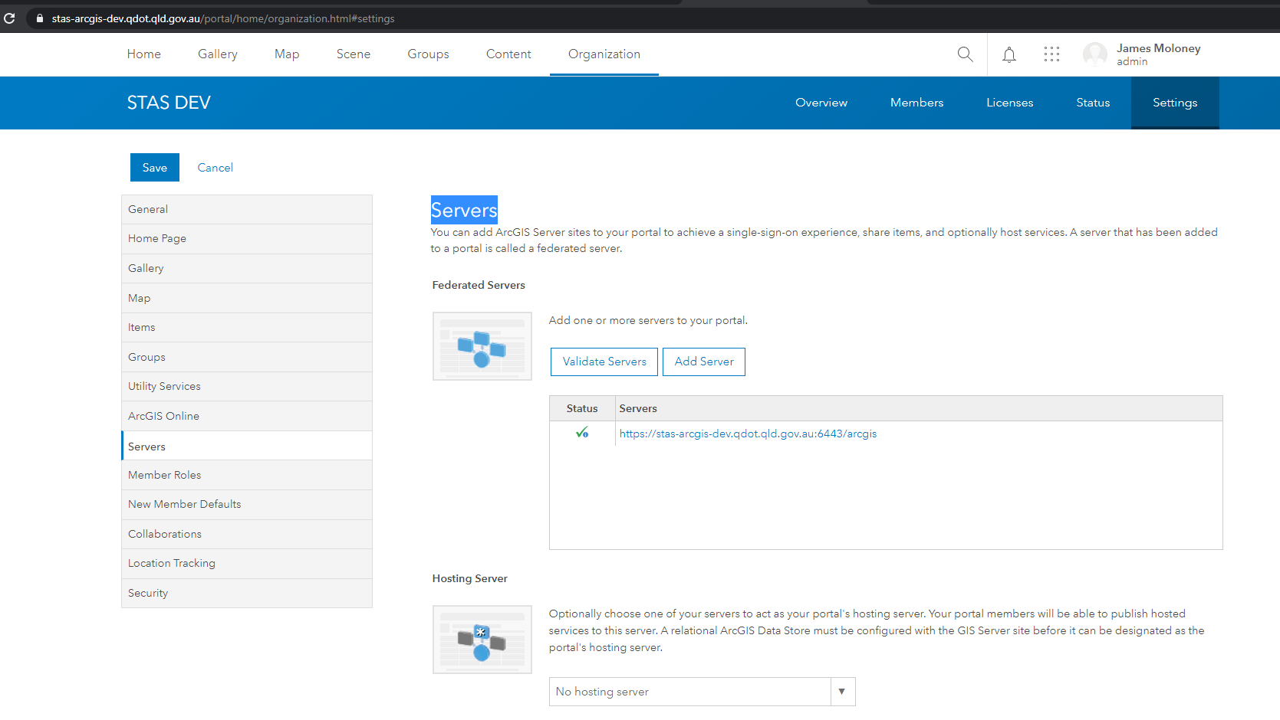

# Hosted Datastore for Portal

Portal for ArcGIS requires a datastore to host it's content (feature services, tile services etc).

## Create

To configure a datastore, launch the datastore wizard from the start menu.

Enter the required details. See example below

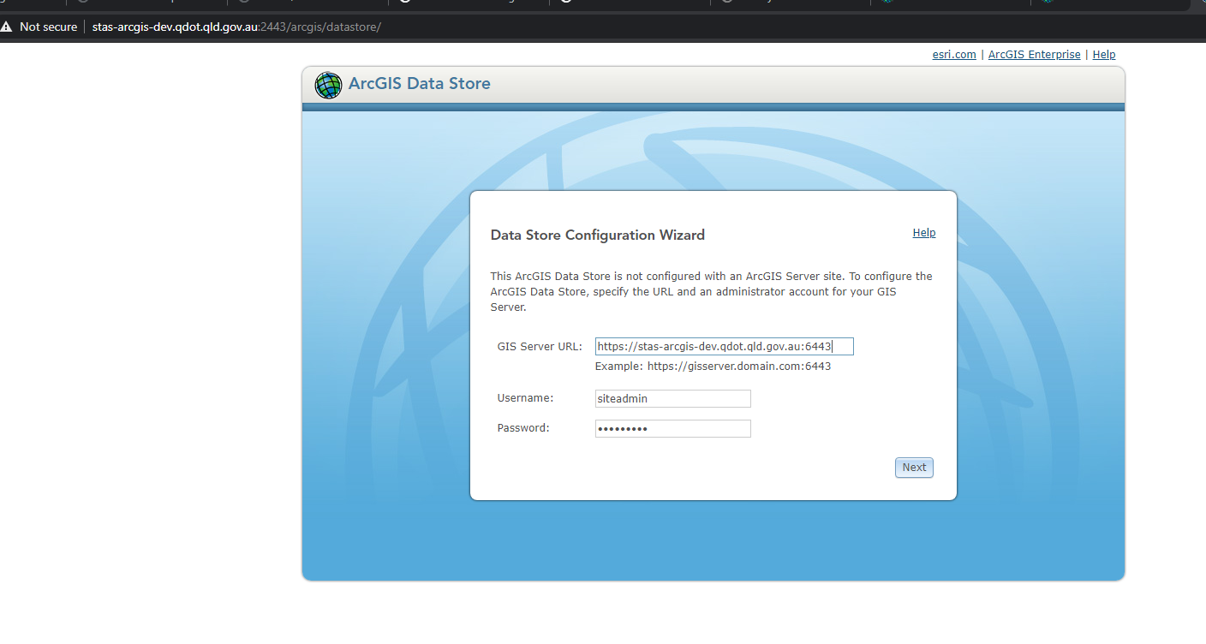

Specify the content directory. Accept default unless you are storing content on another drive/box

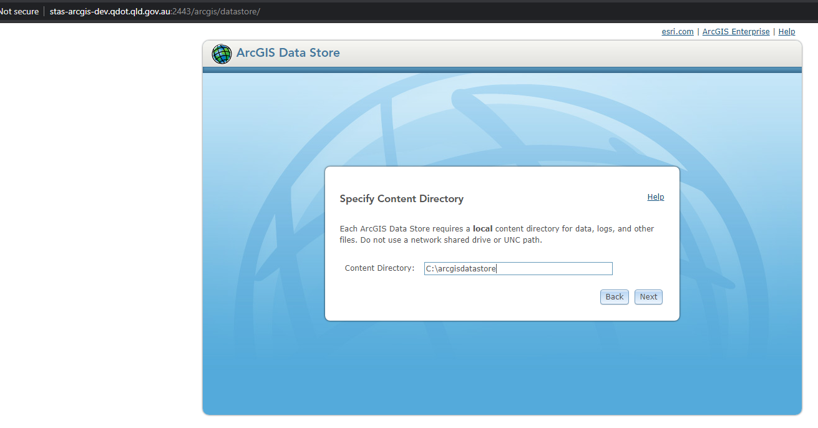

Select the data types for the data store

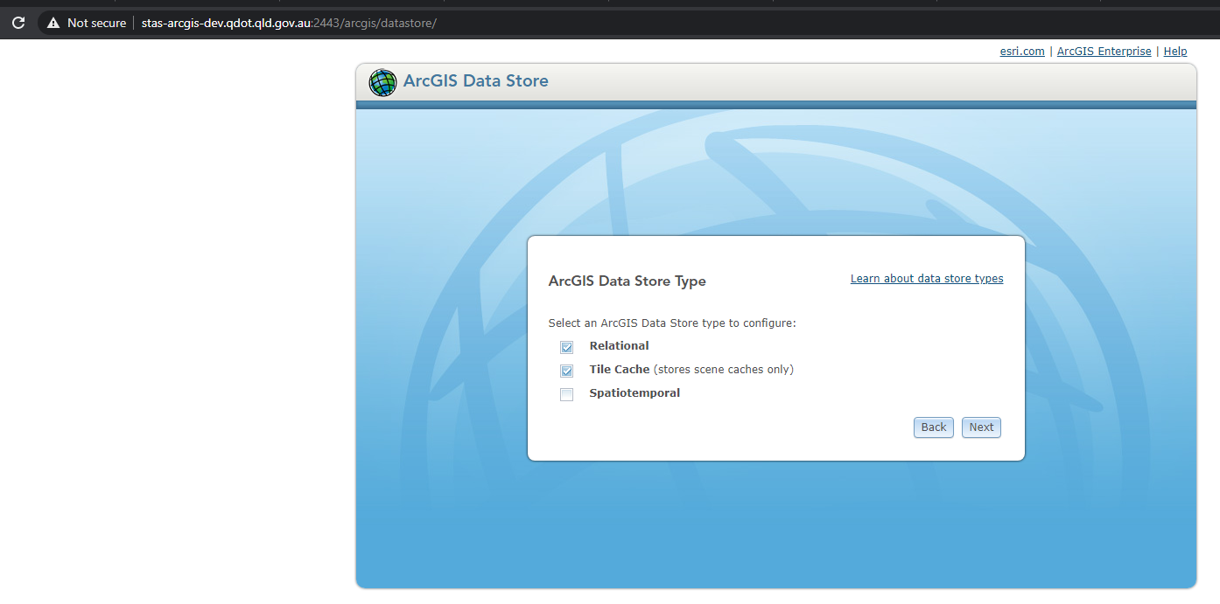

Click finish

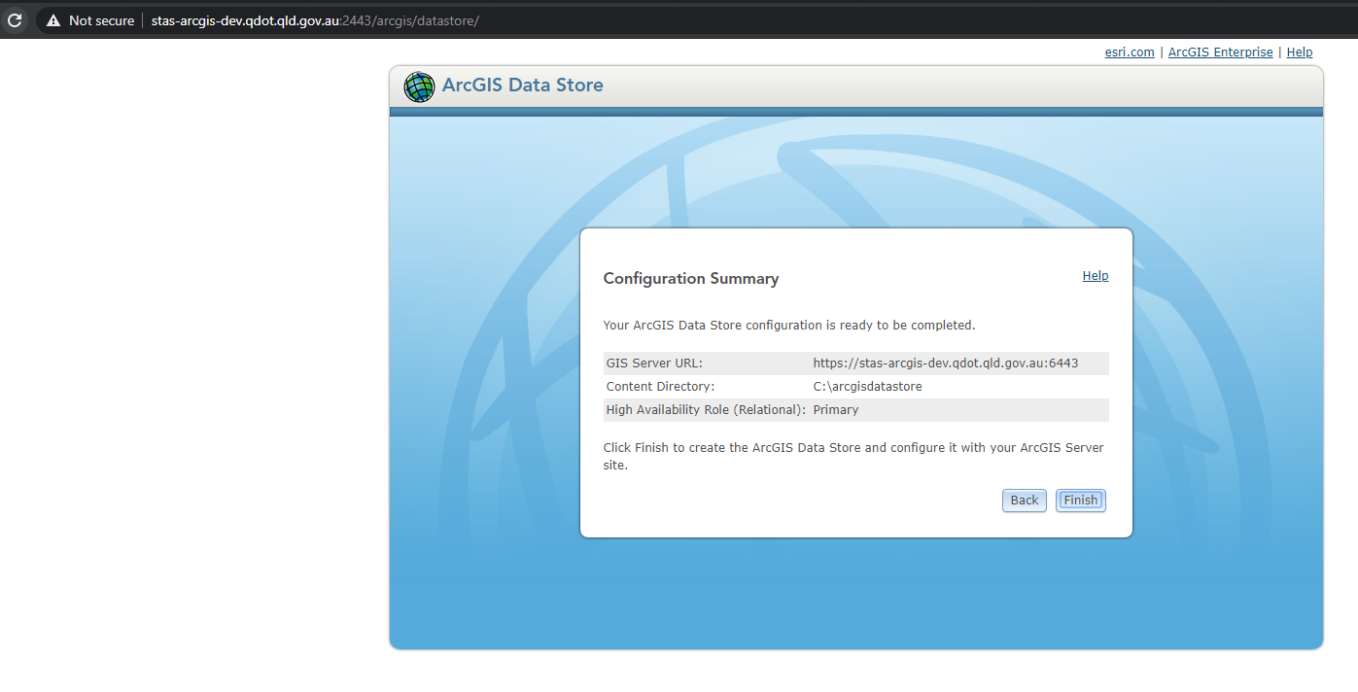

You should receive a success message indicating you can use port url to access services etc.

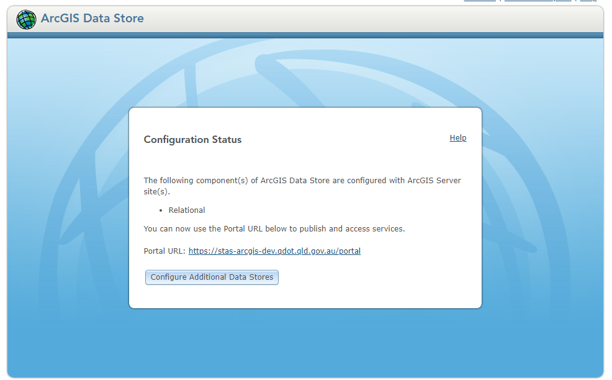

## Get Database Credentials

As the hosted datastore was created by the datastore wizard, you have no idea what usernames and passwords were created for all of the tables, schemas, in the PostgreSQL database.

There is a way to access this info.

To access this info

1. Open command prompt as administrator.
2. Navigate to the datastore tools directory - **C:\Program Files\ArcGIS\DataStore\tools**
3. Type the command **listadminusers**
4. Hit Enter

You should now have all of the admin account usernames and password of the hosted datastore database.

Example

Database Admin User: adm\_wjhss / a-password

Database Repl User: dsrepuser / a-password

GDB Admin User: sde / a-password

You can now use a database management tool such as pgAdmin to log in and administer the database.

## Login to the Datastore Database

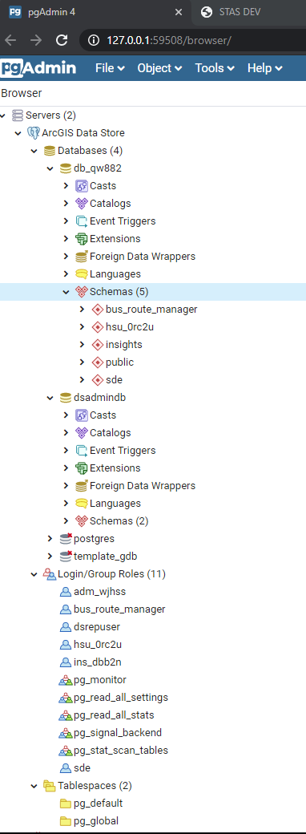Download and install pgAdmin

Create a new server in the top right

Create a new connection. [See Get Database Credential](#_Get_Database_Credentials)

For more info

Host: **localhost** (or ip address)

Port: **9876** (arcgis datastore runs on this port, not default pg port)

Database: **dsadmindb** (this is the admin database)

Username: **adm**\_**wjhss** (this will be different for you as

these are atomically generated)

Password: returned by the **listadminusers** cmd above

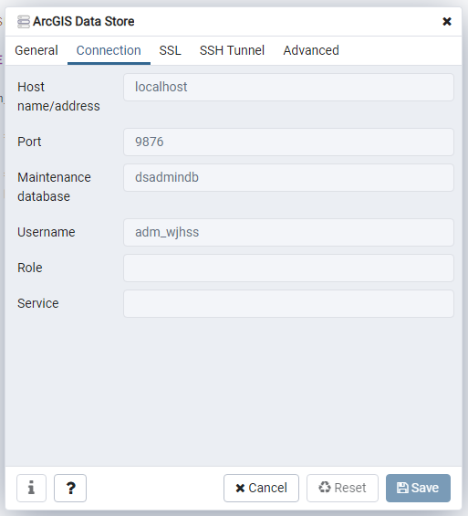

## Creating a new Login Role

Creating a new login role enable to access the datastore with a different user other than the ArcGIS hosted data store generated users. This give you the ability to grant different privileges etc and delegate ownship of data, write views and materized views and publish these as services accessible in portal.

Right on the Login/Group Roles



Enter a role name

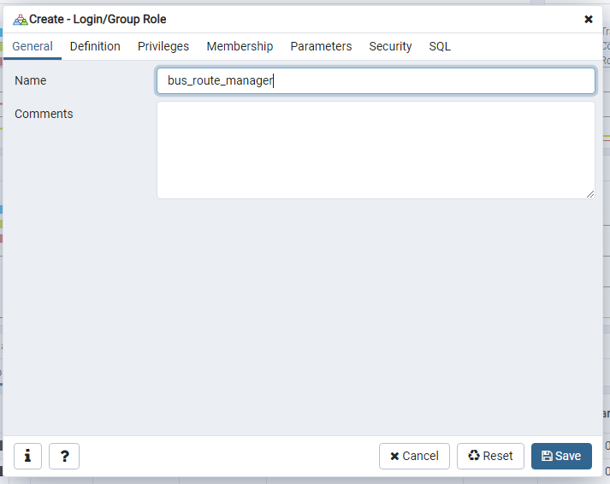

A password

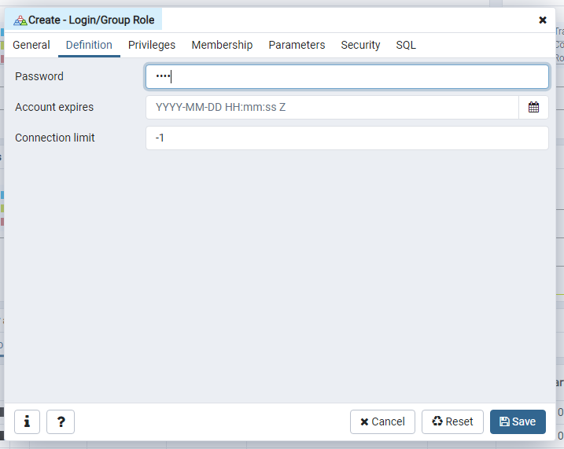

Select privileges

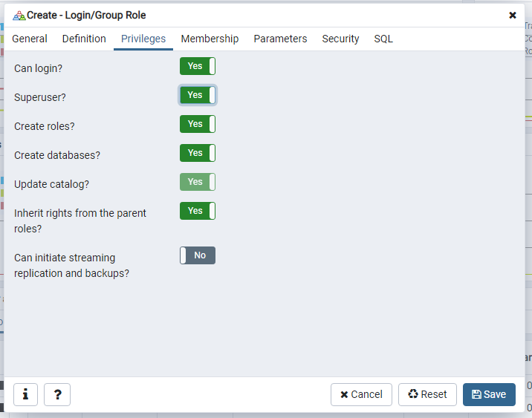

In this example, the bus route manager will be allowed to do everything

Then click save.

Before you can create a database connection with the new login role you will have to modify the pg\_hba.conf file

C:\arcgisdatastore\pgdata\pg\_hba.conf

Copy the settings in bth IPv4 and IPv6 for the default user and past on new line and change the user\_name

See below

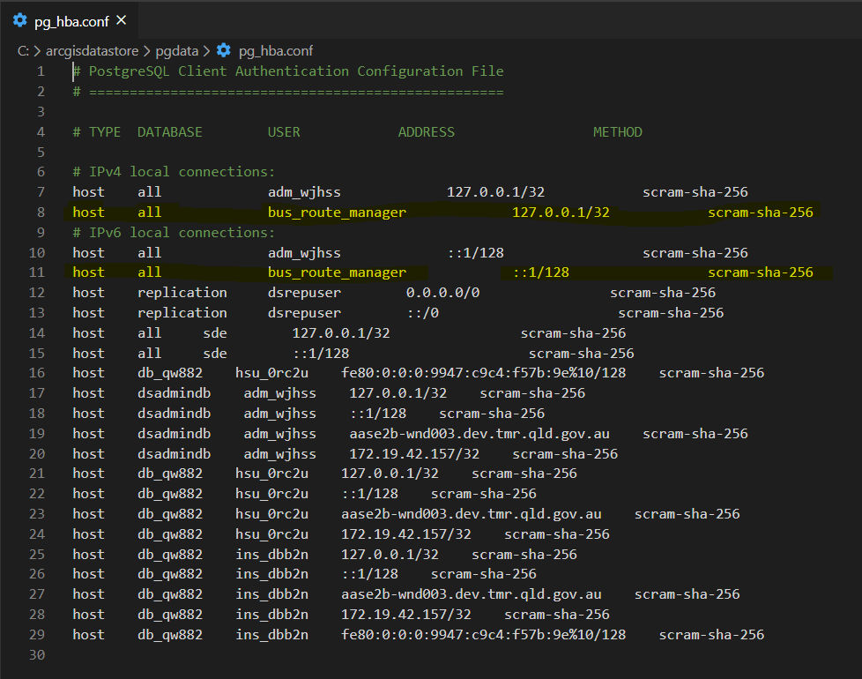

MAKE A BACK UP OF THIS FILE IF YOU ARE NOT SURE ABOUT WHAT YOU ARE DOING

## Creating a new Schema

Now that you have a new login role, and you have updated the pg\_hba.conf file, you can log in to pgAdmin with that user and create a new schema.

NOTE: The schema name must be the same as the login role name. This due to restriction of publishing tables/layers into the database from ArcGIS Pro

Right click on the hosted datastore database and click create new schema

# SDE Connection

## ArcGIS Pro

## ArcGIS Server

# Creating and Publishing Data

## Create Feature Layer

## Create Spatial View

## Create Materialized View

## Publish Feature Class or View as a Service